NAME

Love My Closet

Purpose of This Guide
This is a resource developed specifically for you.

Your 4 C’s
The 4C’s consist of 1) cloth, 2) color, 3) cut, 4) comfort. These are the essential elements in crafting a successful outfit.

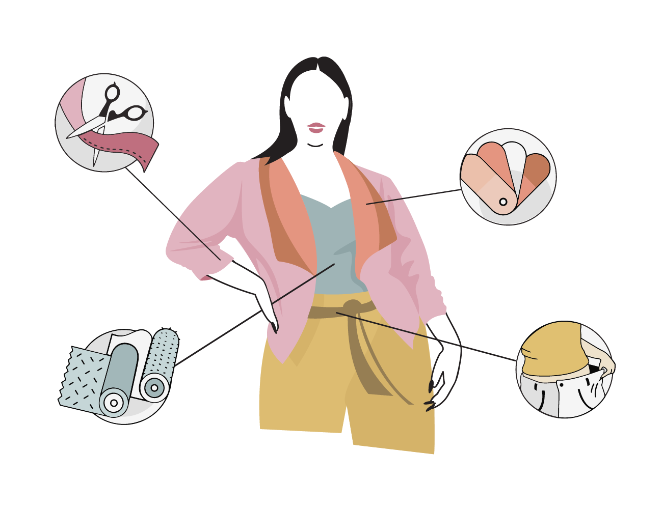
4C’s & Accessories | To do | To avoid
Cut
Color
Cloth
Comfort
Accessories

Great Looks On Your

PLACE A PHOTO OF YOURSELF HERE

Best Cuts For You

Blouses & Tops
IMAGE DESCRIPTION | IMAGE DESCRIPTION
IMAGE | IMAGE
IMAGE DESCRIPTION | IMAGE DESCRIPTION
IMAGE | IMAGE

Bottoms
IMAGE DESCRIPTION | IMAGE DESCRIPTION
IMAGE | IMAGE

Dresses
IMAGE DESCRIPTION | IMAGE DESCRIPTION
IMAGE | IMAGE

Things to do to make your outfits feel more FRESH
Hey, we all get in a rut sometimes. Use these pointers to help make your outfits feel fresh.

Accessories
- Pull out that jewelry box and search for an earring or necklace you haven’t worn in a while.

Scarves
- (Resource: In Style - Different Ways to Wear a Scarf)

Layering
- Adding layers to a look can make it feel more “put together” and sophisticated. If you have the jewelry and a scarf, try adding a blazer or a cardigan to your look. You can also try layering necklaces.

Shoes
- Try on a pair of shoes you haven’t worn in a while.

Tights
- Try a variation in the color or style of tight you wear.

Recommendations & Reminders

Recommended Purchases
- Depiller to make your clothing look like new. On Amazon >
- 2 fitted bras from a trusted retailer. I love Soma, but anywhere that offers customized fittings and quality bras that will last will work. Having a couple of bras that fit you beautifully will make a world of difference!

Reminders
- Consistently curate: As soon as your mind or reality tells you something isn’t serving you any longer, donate or consign it. This is the golden rule for knowing when to get rid of items.
- Shopping guide

